HTTP packets capture lab:

Http web server: 192.168.139.137
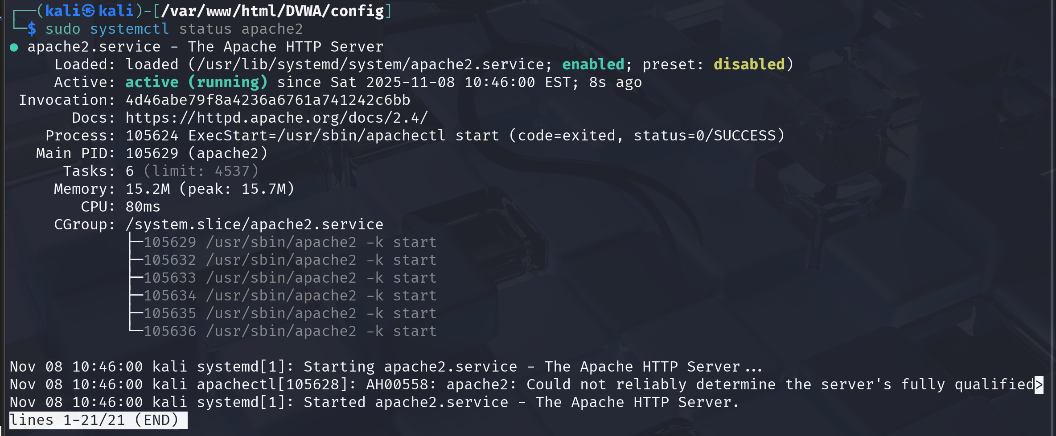
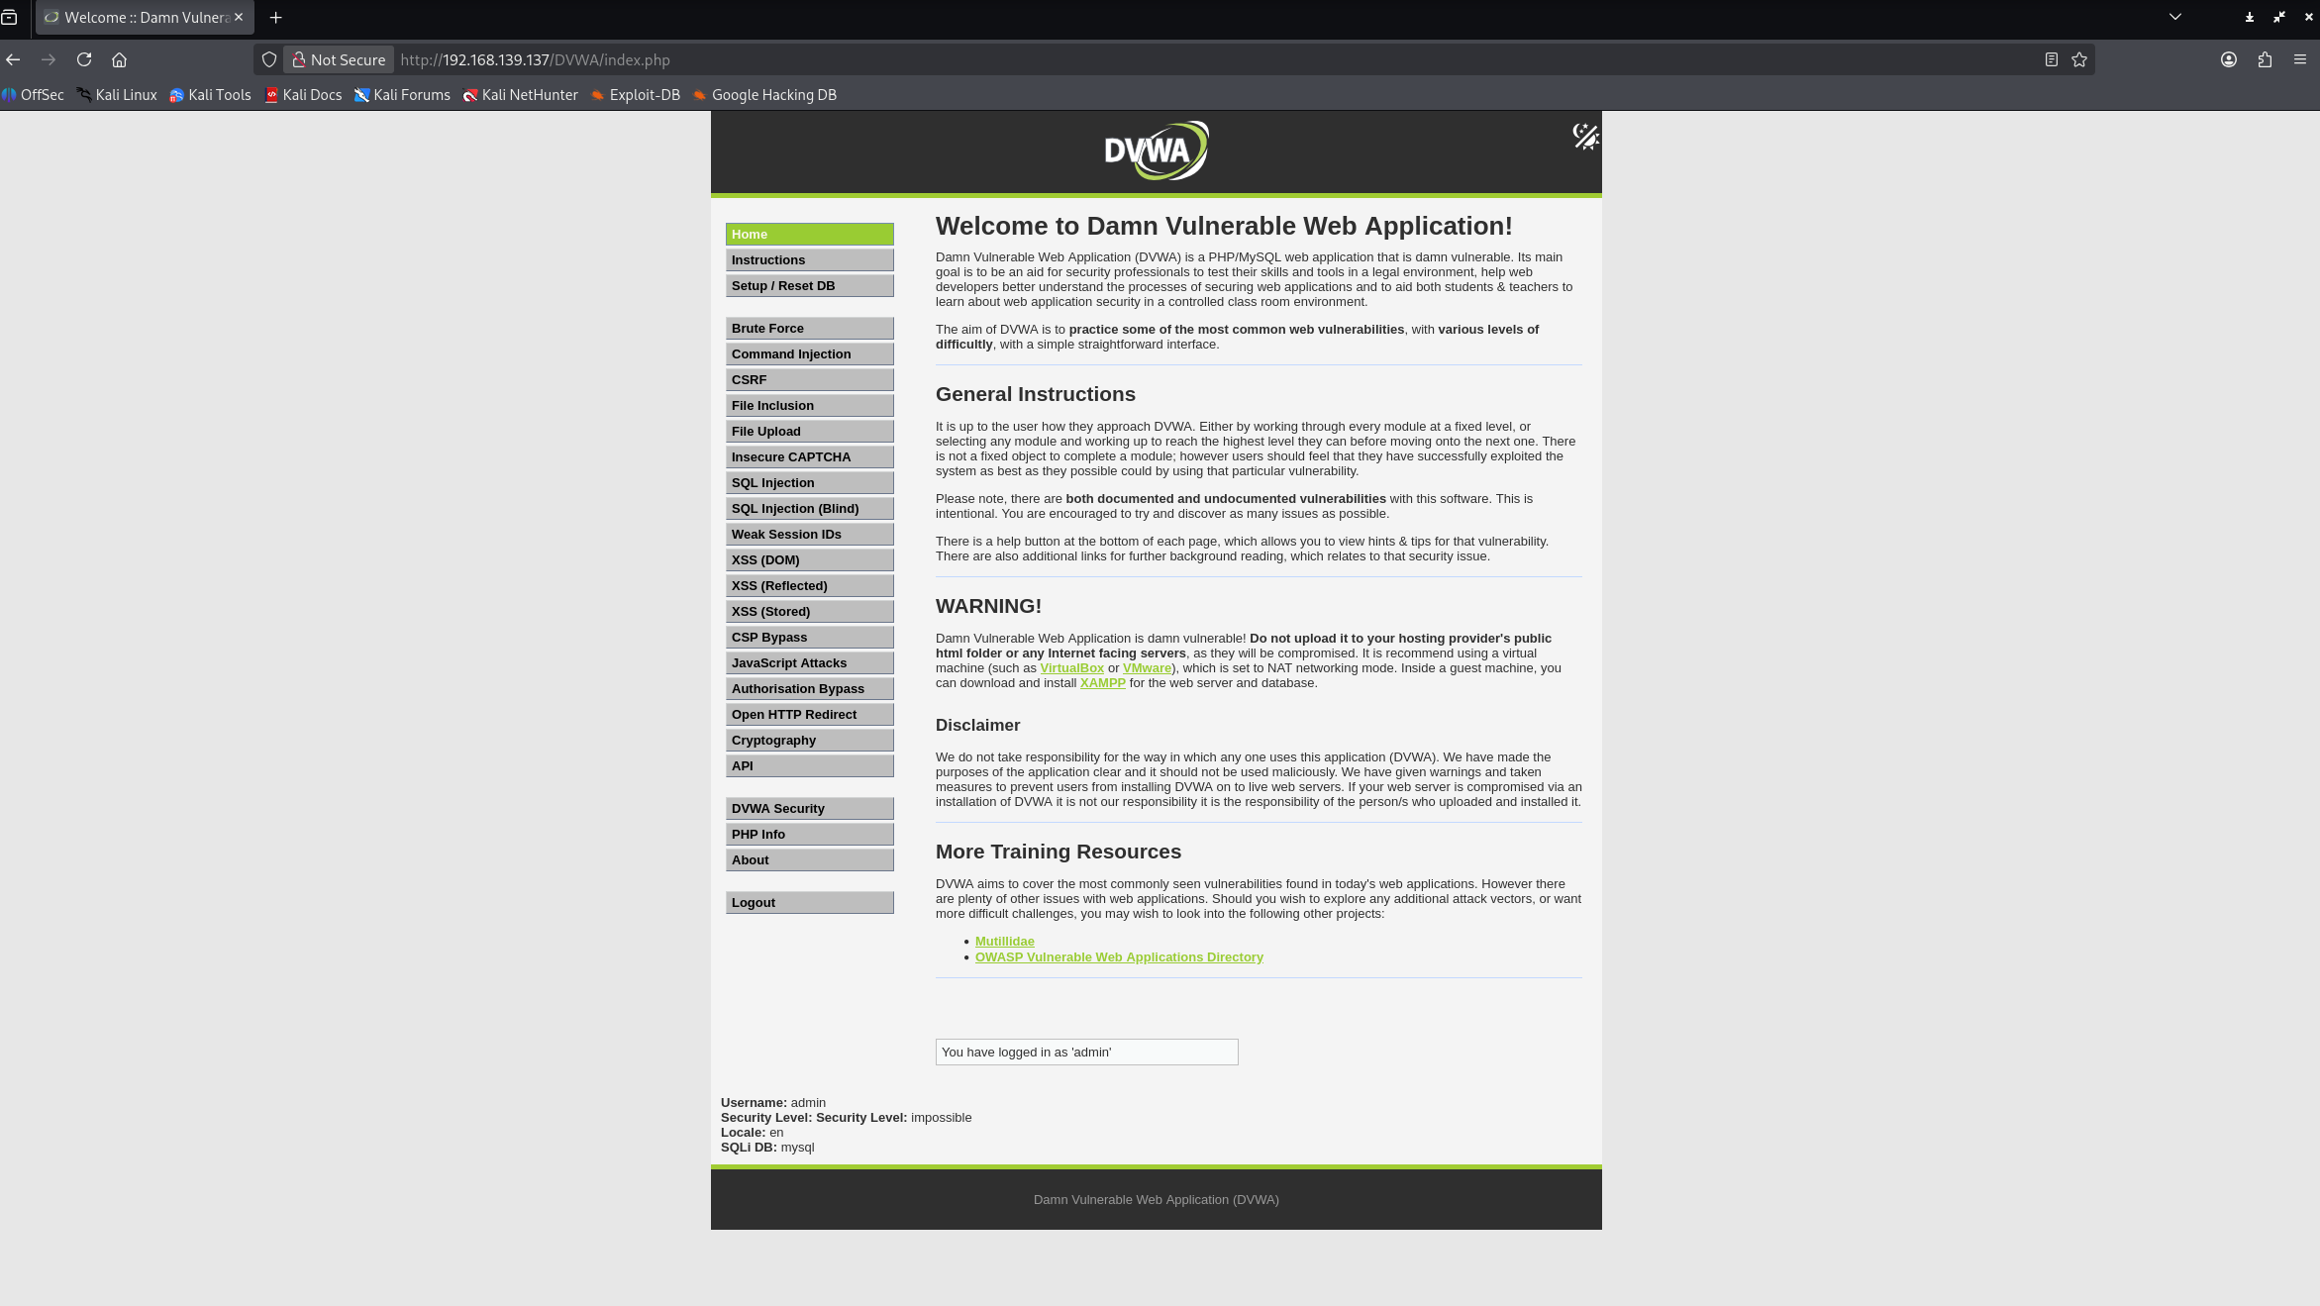
This is the http web server that I have hosted on local host with ip 192.168.139.137

Database server: 192.168.139.136
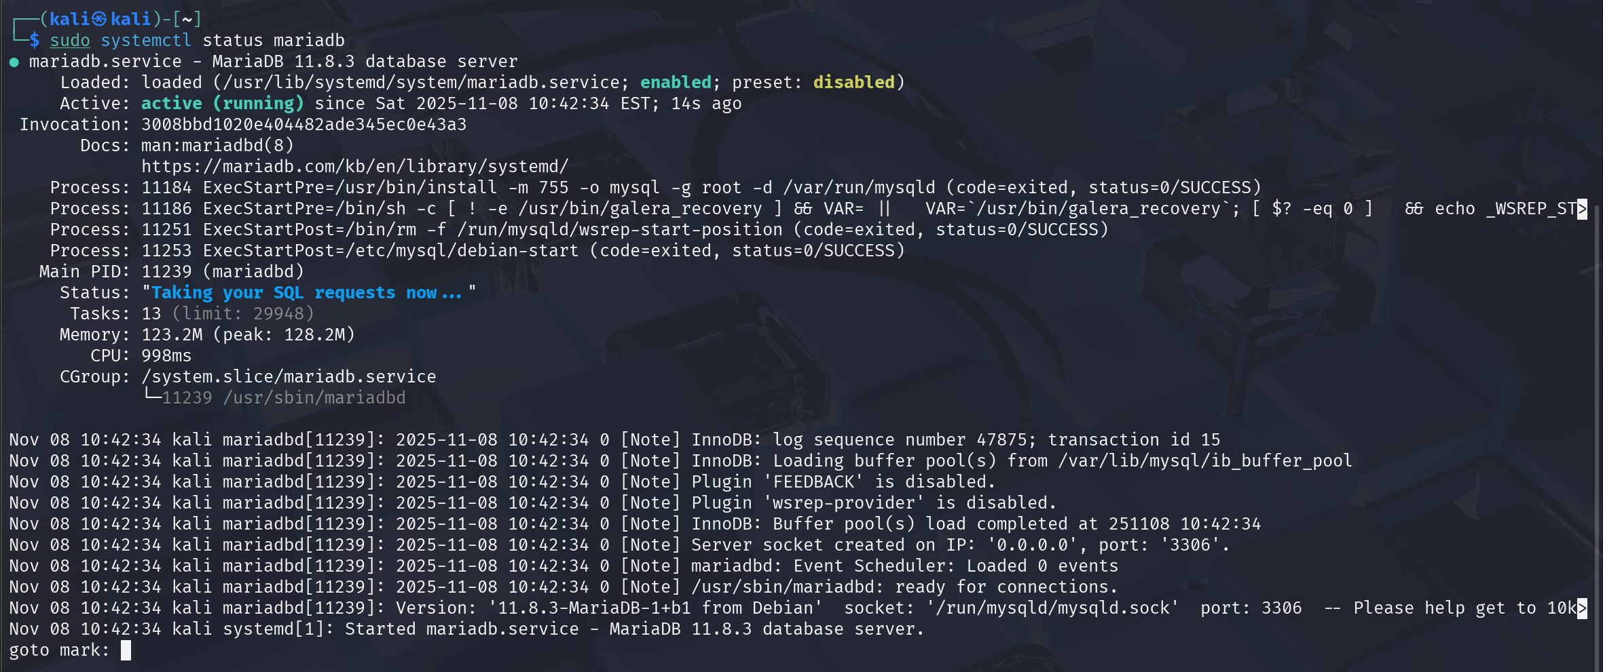
This is the database server for the http web server that save the user information

So now I will use another victim Kali VM to access this website and login with the username and password
Victim: 192.168.139.138

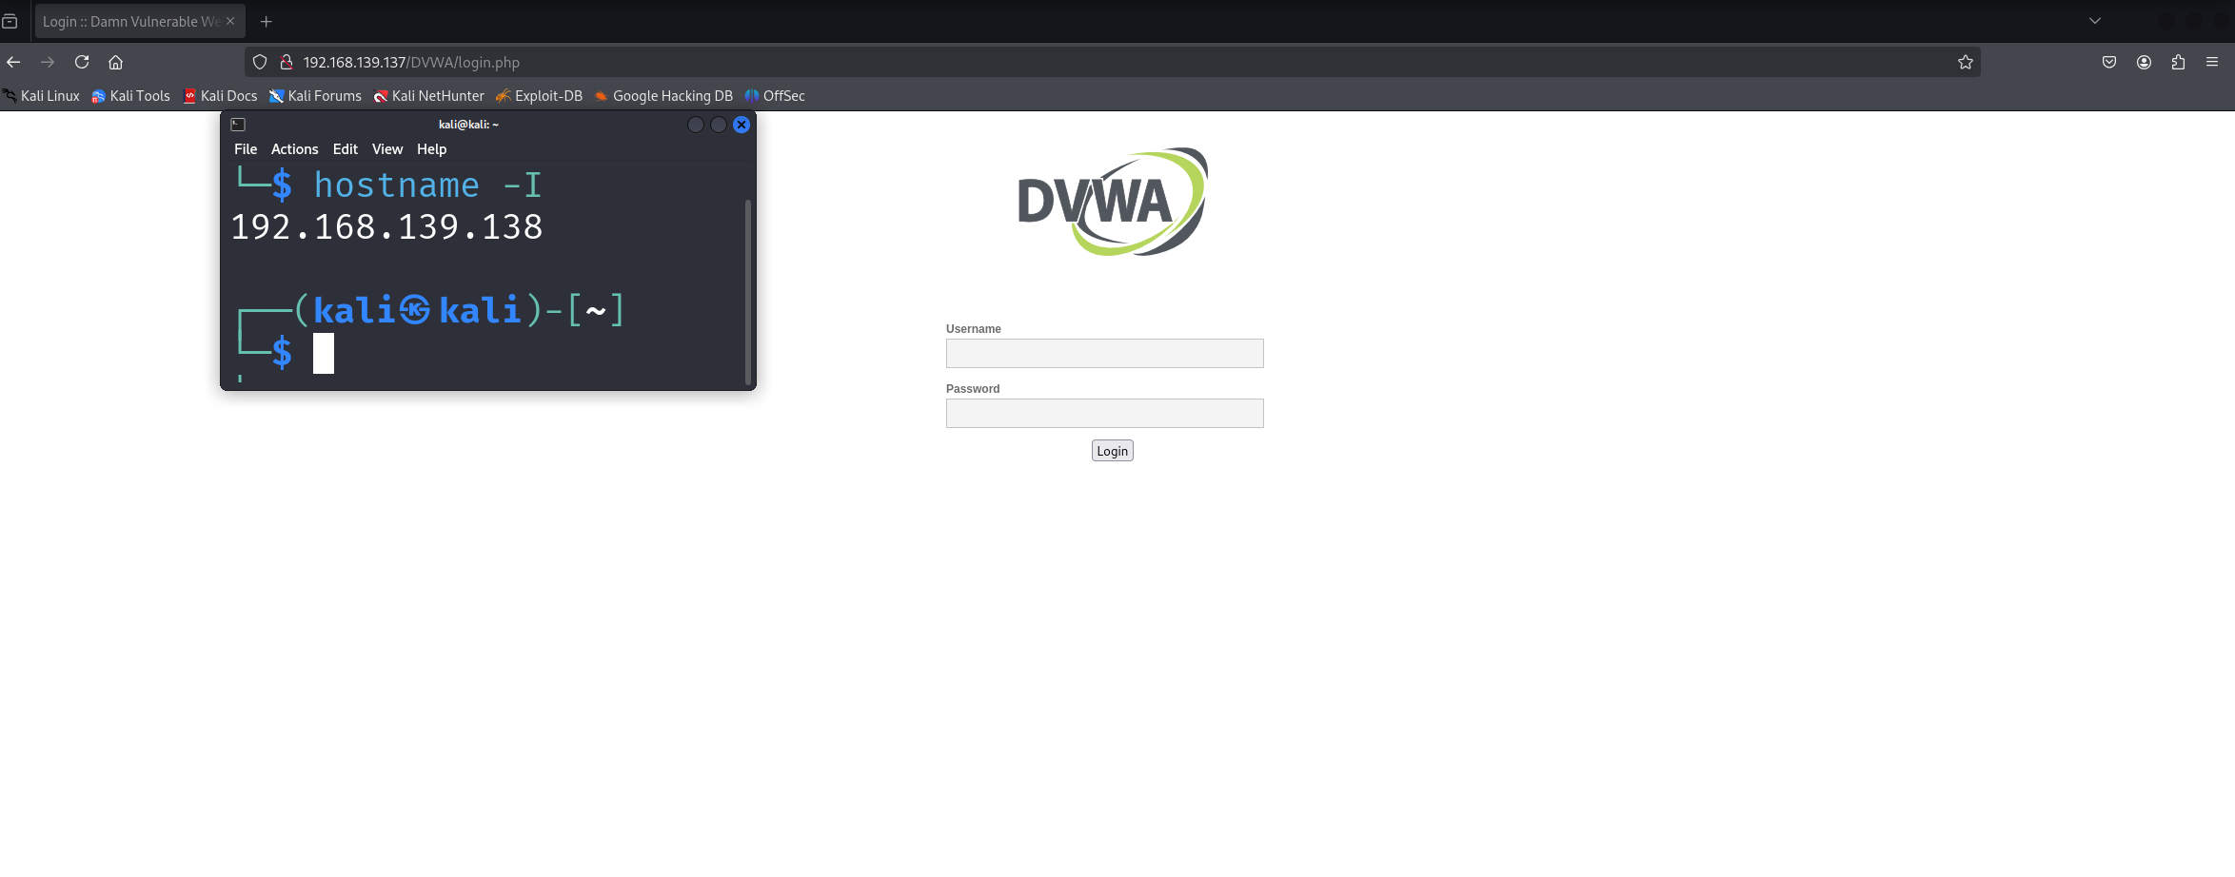
So I have accessed to the website on the local network and now I will login with
Username: admin
Password: password
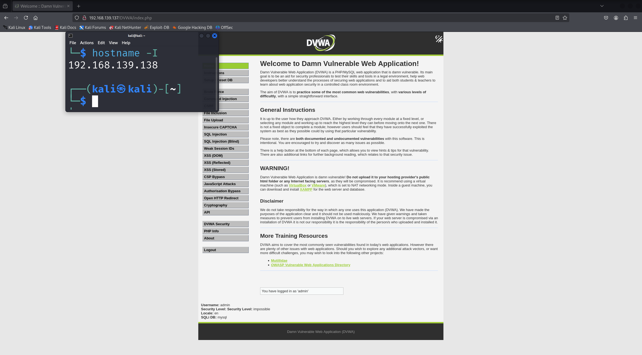
Successfully login with the credentials and now we will look at the attacker machine, this is how magic appear when a website use HTTP.

Attacker: My windows host machine
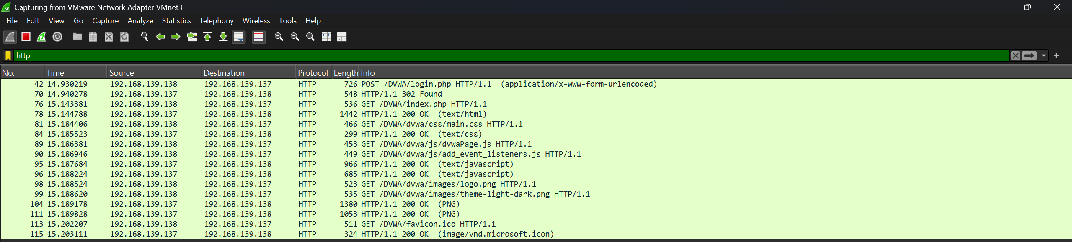
BOOM!!! With just a wireshark tool and a simple filter for HTTP, we have capture all the communications with plaintext from victim and the web server. Now lets look at the packet that contains username and password
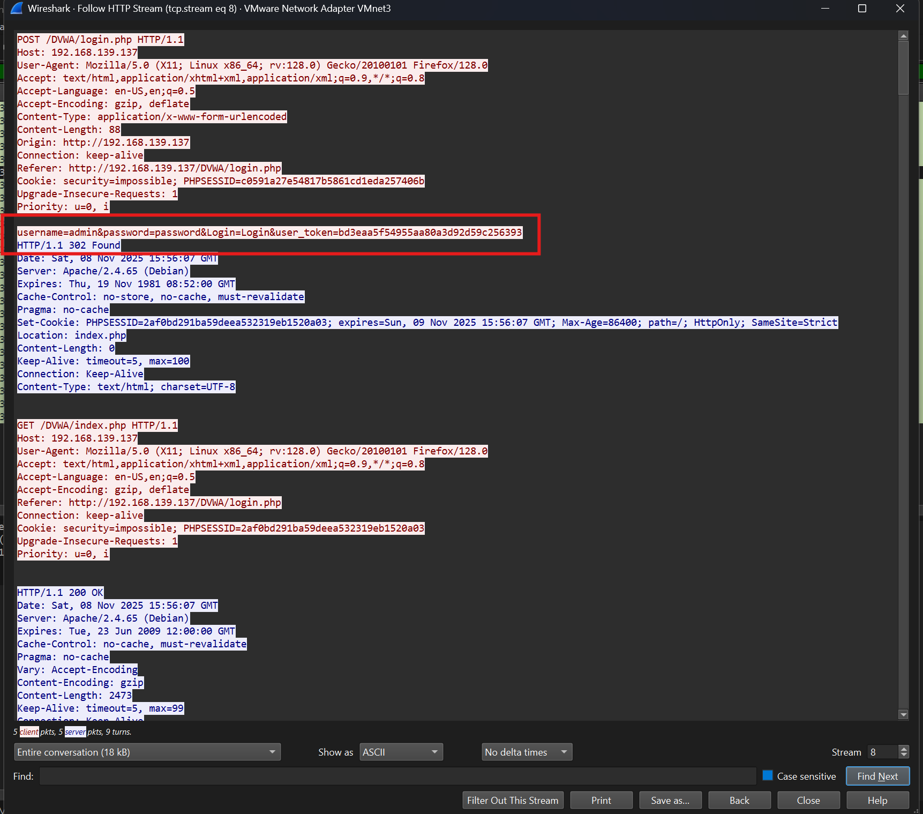
Okay, that is so interesting, we can see all the user credentials in plaintext, I did not even have to decode it. The username is admin and the password is password.

In conclusion, this lab I have hosted a web server on one kali VM with ip address 192.168.139.137 and a database in another kali VM with ip address 192.168.137.136 and used one kali VM acted as a victim with ip address 192.168.139.138. The kali victim access the HTTP web server and login with username and password. On the other hand, the attacker machine turned on the wireshark to look for some chicks, and then a http packet with login credential appear, the attacker just click using the UI of wireshark to see inside the HTTP packet. That is why we need to avoid using HTTP and move to HTTPS for a secure practice.

